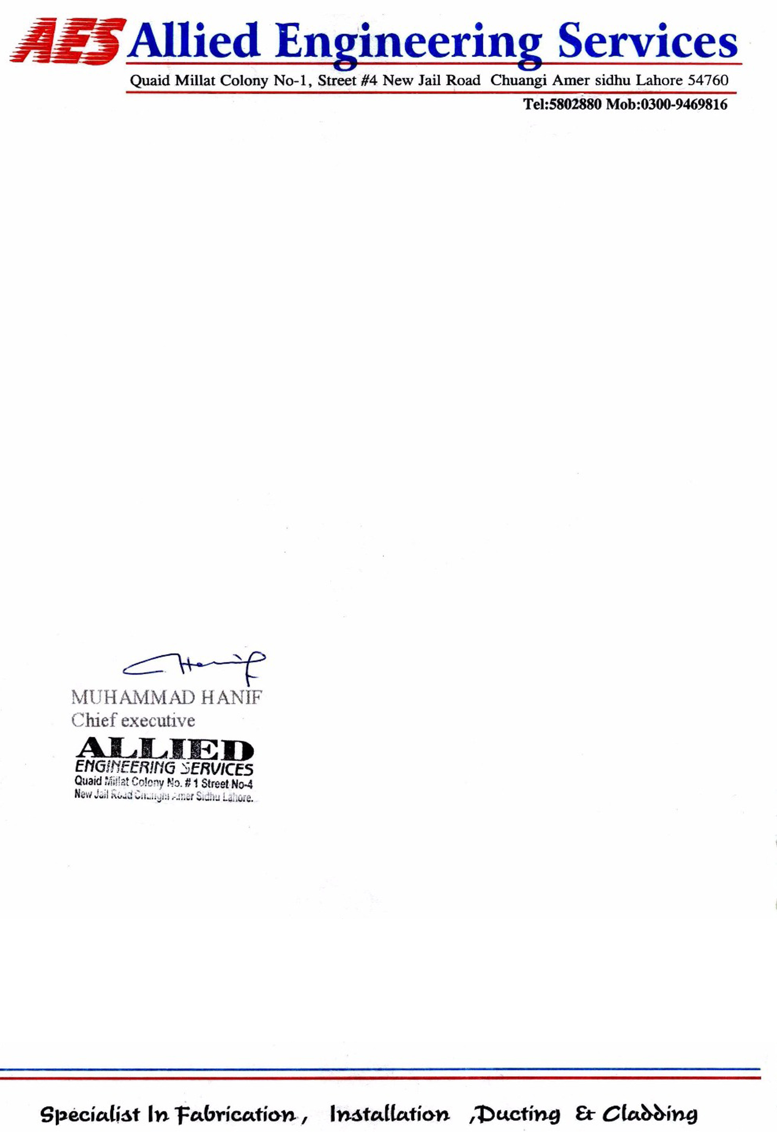

**TO WHOM IT MAY CONCERN**

It is certified that Mr. <Name> S/o <fname> has worked with us as a <Designation> at Allied Engineering Services at Hubco Power Plant Narowal from <From> to <To>.

During this period, his services were found satisfactory. We wish him every success in his future life.